Name: Shreyash Patil

PRN No: 22510039

Batch: B2

**High Performance Computing Lab**

**Practical No. 8**

**Problem Statement 1:** Study and implement 2D Convolution using MPI. Use a different number of processes and analyze the performance.

Ans.

Code -

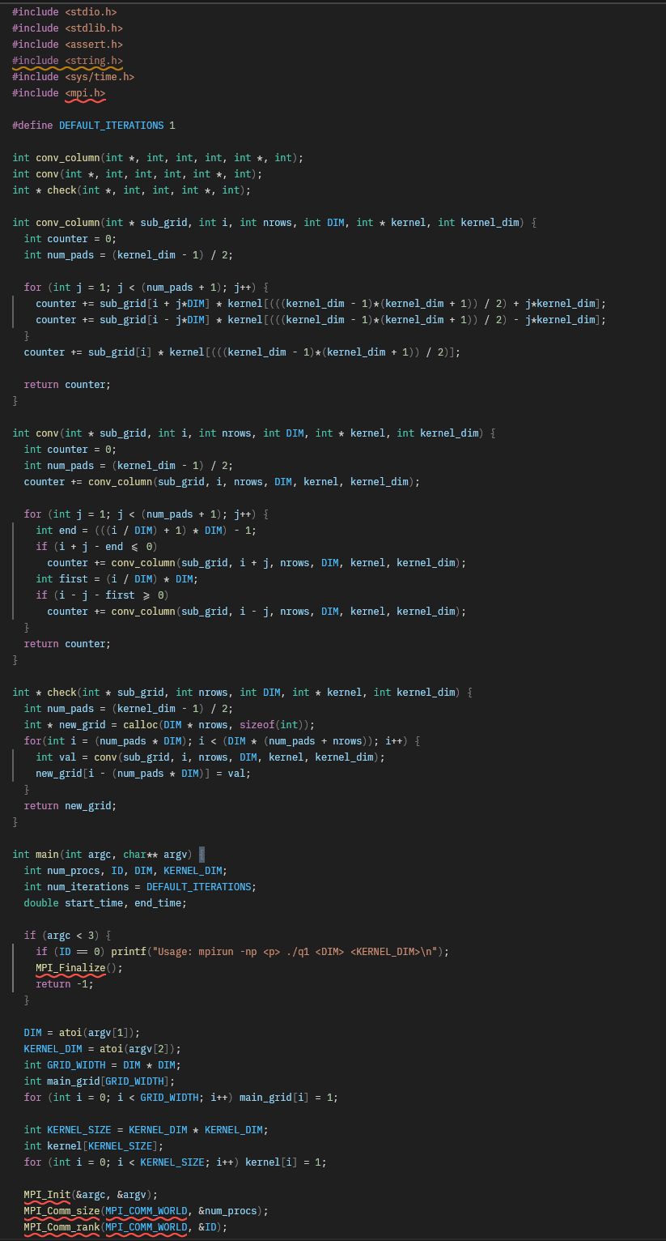

Result graph -

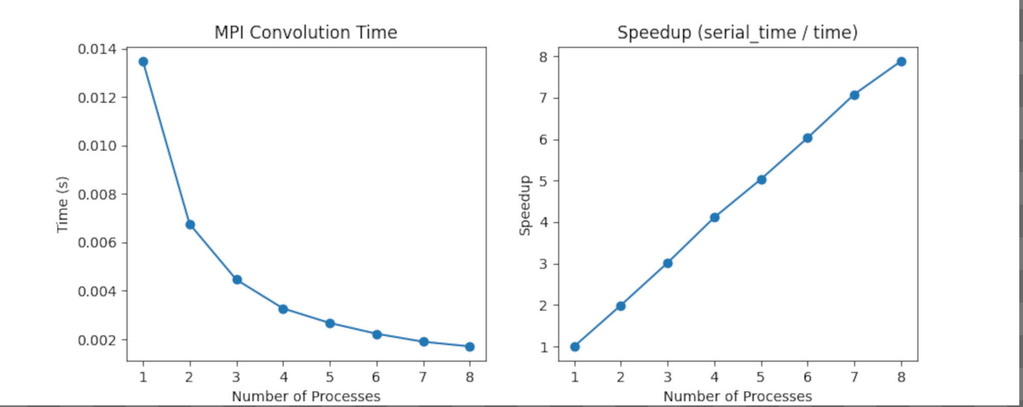

Analysis:

The graph shows that the convolution execution time decreases sharply as the number of MPI processes increases, demonstrating excellent scalability and parallel efficiency. The corresponding speedup curve rises almost linearly, approaching ideal performance. This indicates that the workload is evenly distributed, and communication overhead remains minimal, allowing the computation to benefit significantly from parallelization.

**Problem Statement 2:** Implement dot product using MPI. Use different number of processes and analyze the performance.

Ans.

Code:

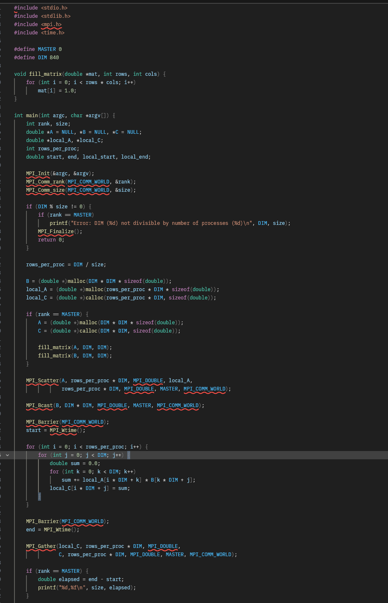

Results graph:

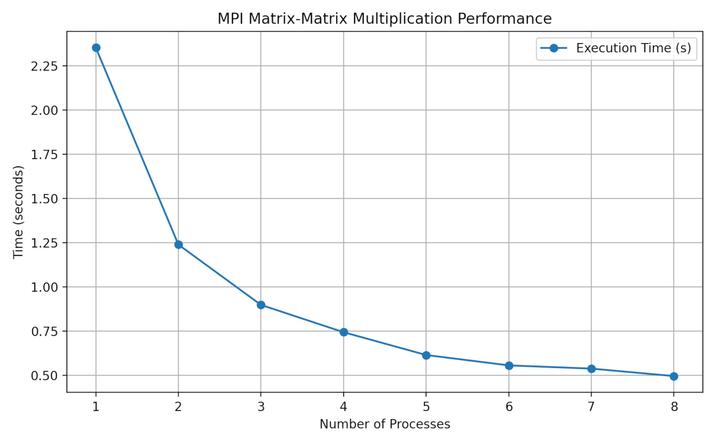

Analysis:

Based on the graph, as the number of processes increases, the execution time for the MPI matrix-matrix multiplication program decreases. This demonstrates the effectiveness of parallelization, as distributing the computational workload across more processes leads to a reduction in the overall time required to complete the task. The most significant decrease in execution time occurs when moving from one to two processes, suggesting diminishing returns as more processes are added, which is a common characteristic of parallel programs.